‘ls’ command:

The ls command is used to list files or directories in Linux and other UNIX based operating systems.

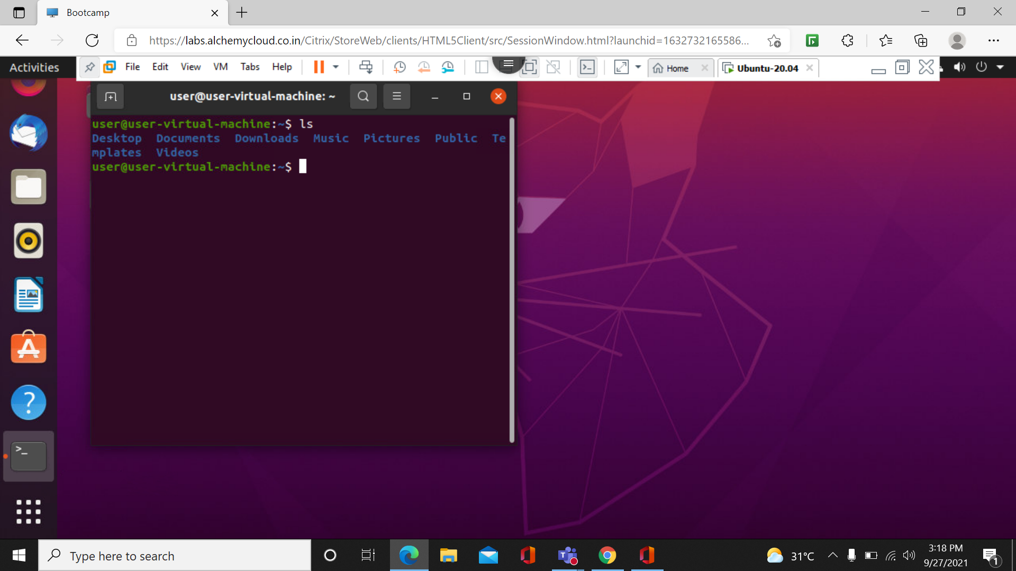

Ls –l command

Ls –l shows files or directory,size,modified date and time,file or folder name and owner of the file and its permission.

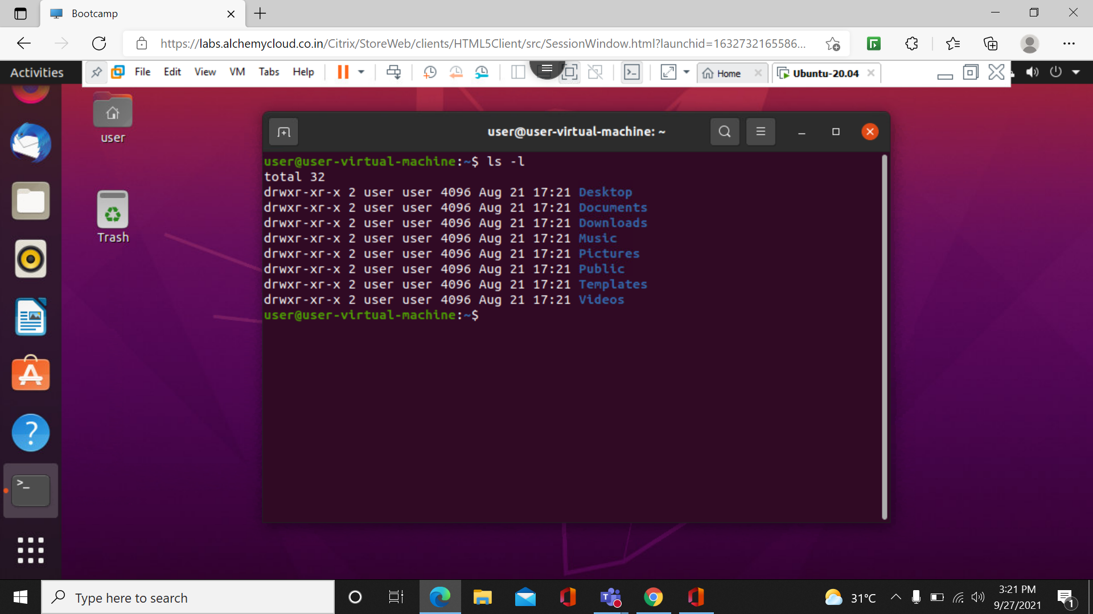

Ls –a Command:

List all files including hidden files starting with ‘.’.

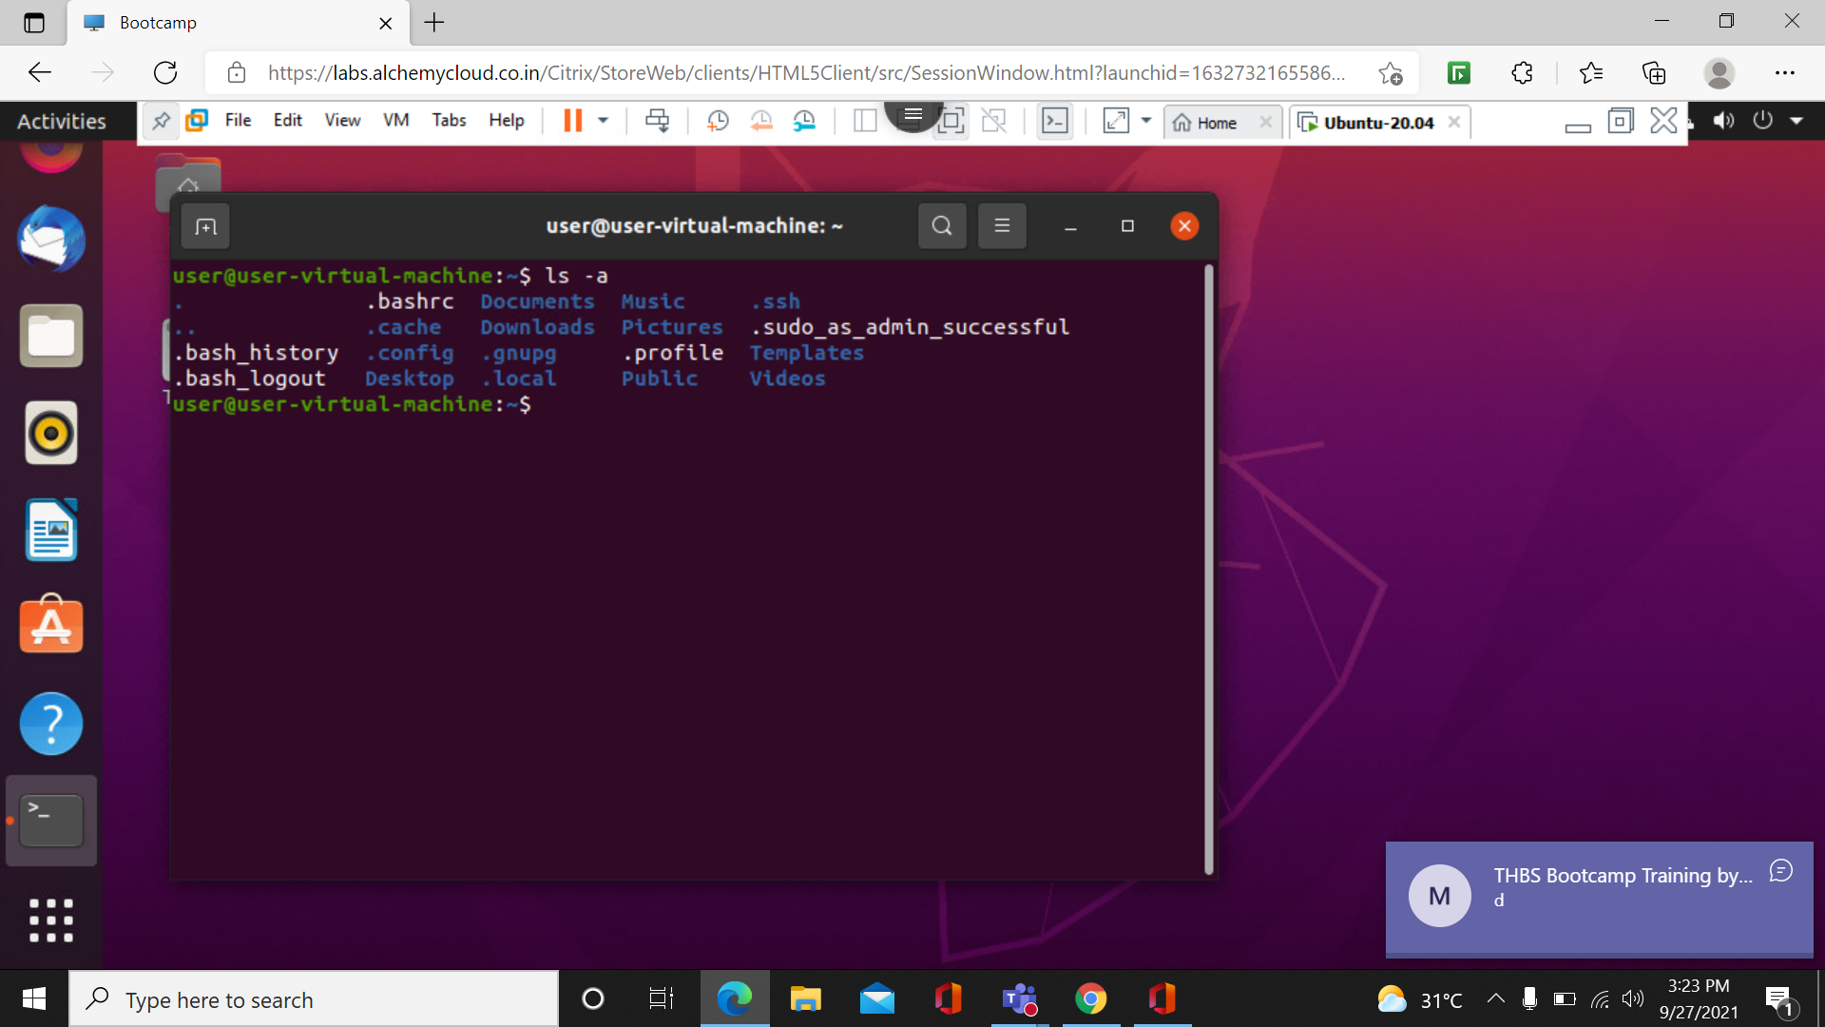

Ls –f Command:

With a combination of lh option ,shows sizes in a human-readable format

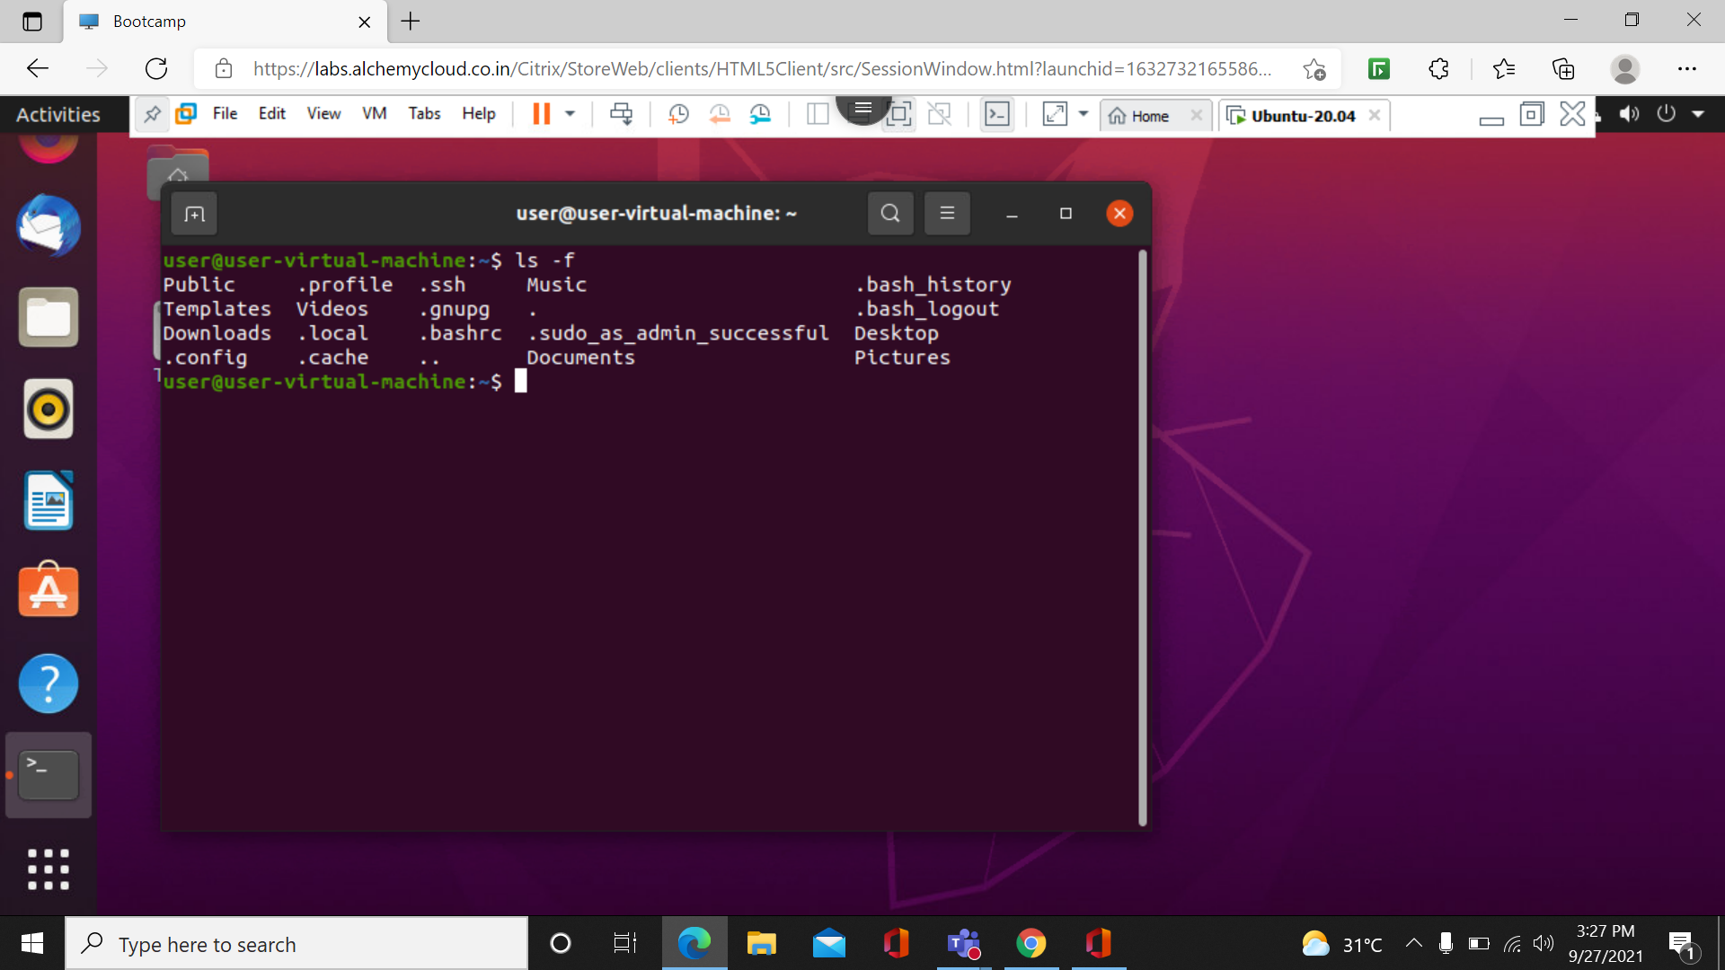

Cd Command:

To move inside a subdirectory:

To move inside a subdirectory in Linux we use.

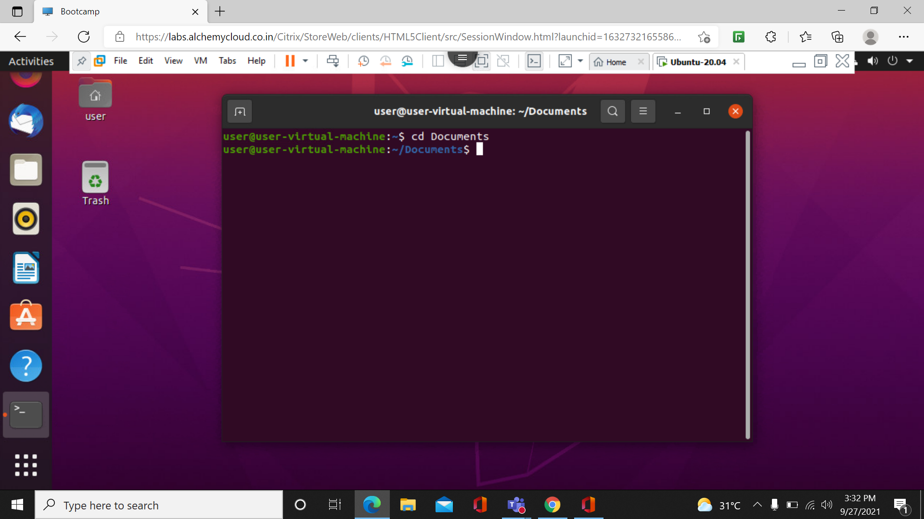

EXIT command:

It is used to close terminal.

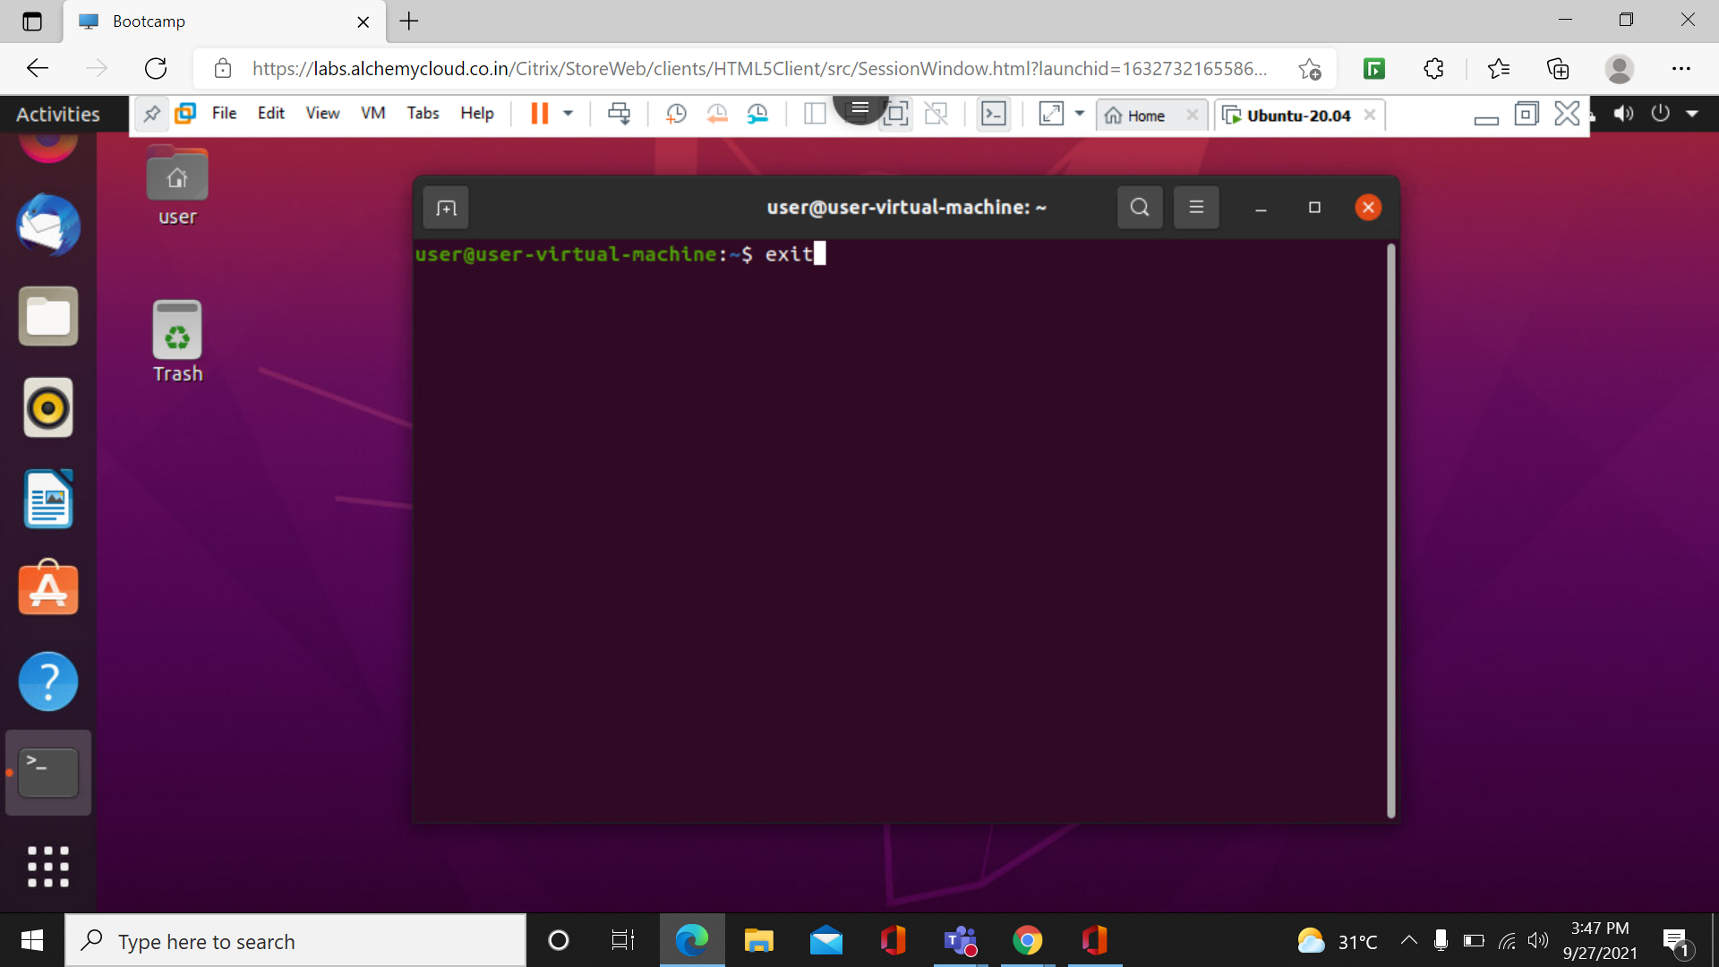

‘cd .’ Command:

It is used to go to previous command

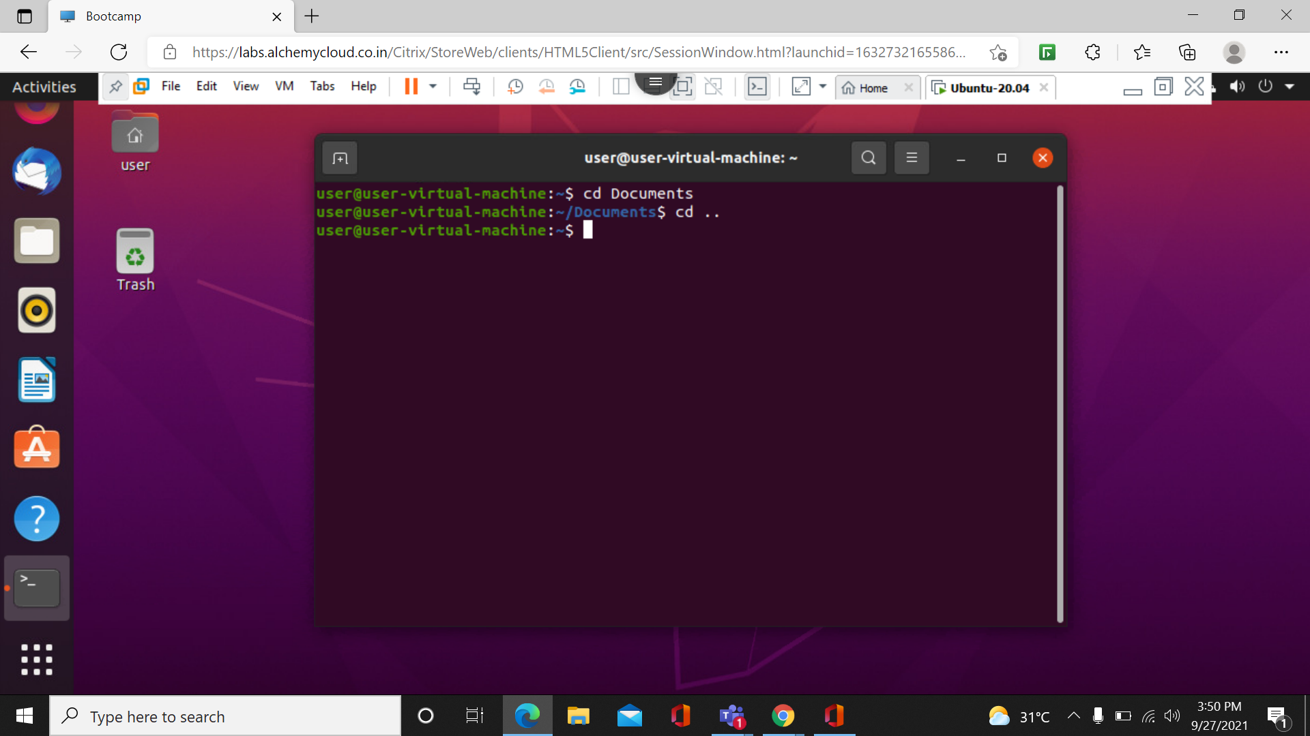

Sudo -I command:

It is used to create password.

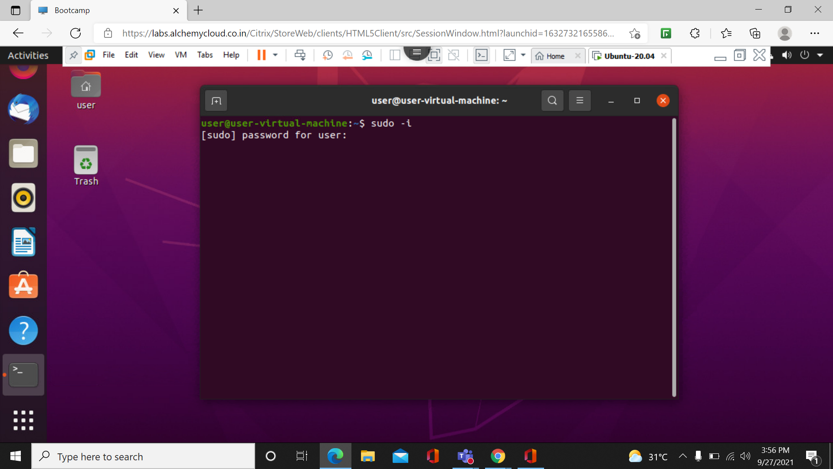

Echo command:  
it is used to print something

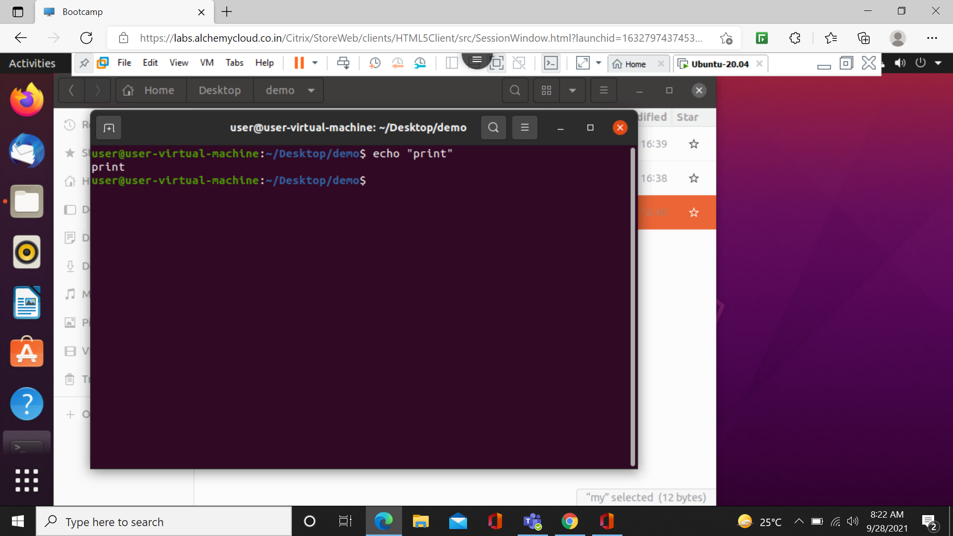

Cd/ command:

It is used to come back to root directory.

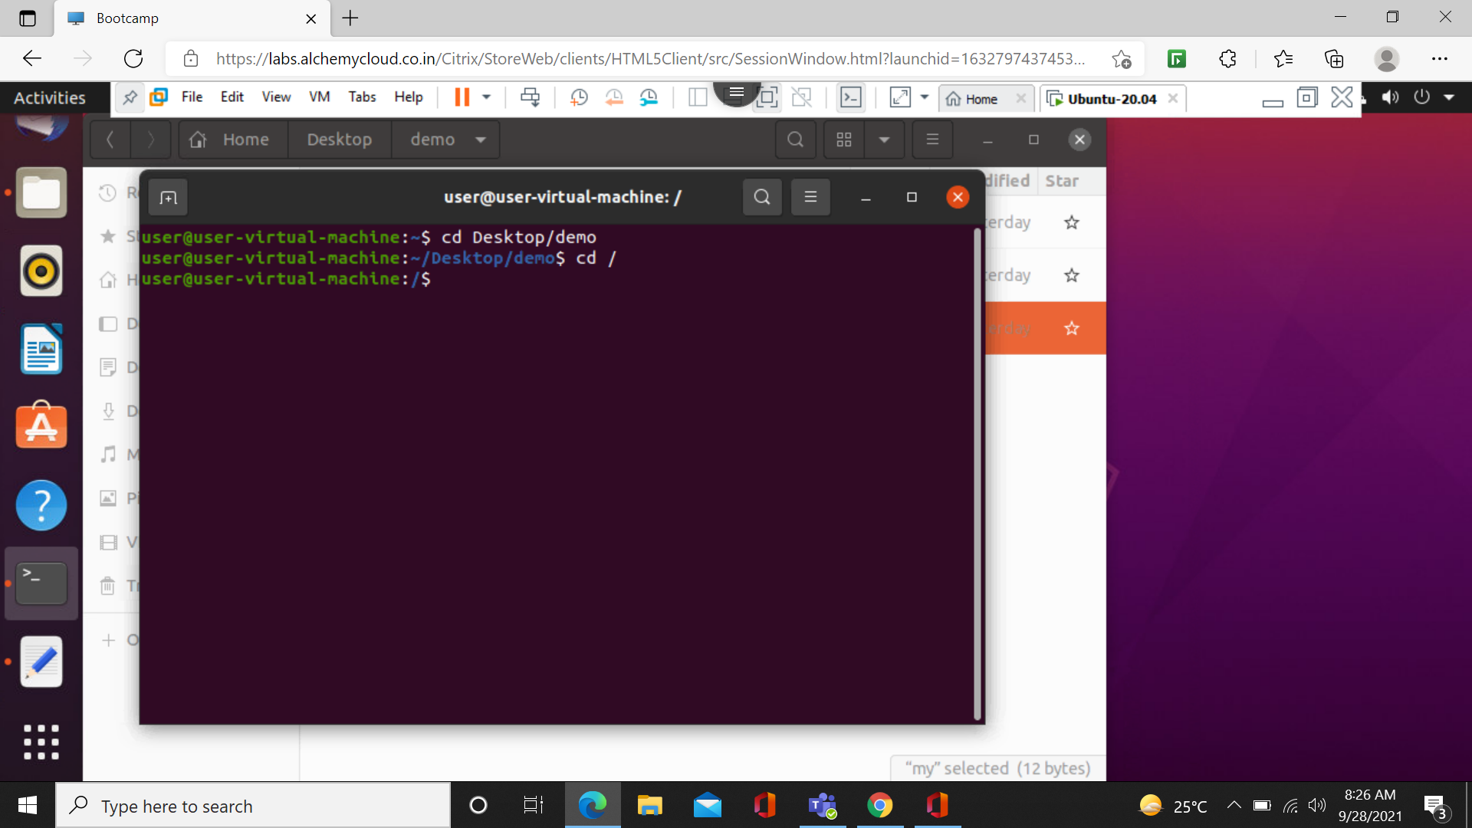

--help command:

This command is used with any other command to get details of those commands.

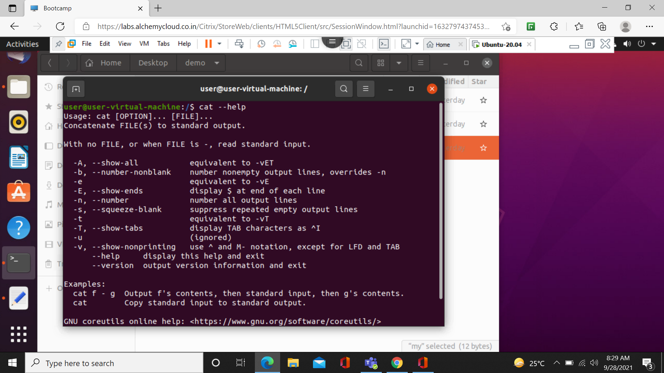

Cat f1>f2 command:

This command is used to transfer data of f1 into f2.

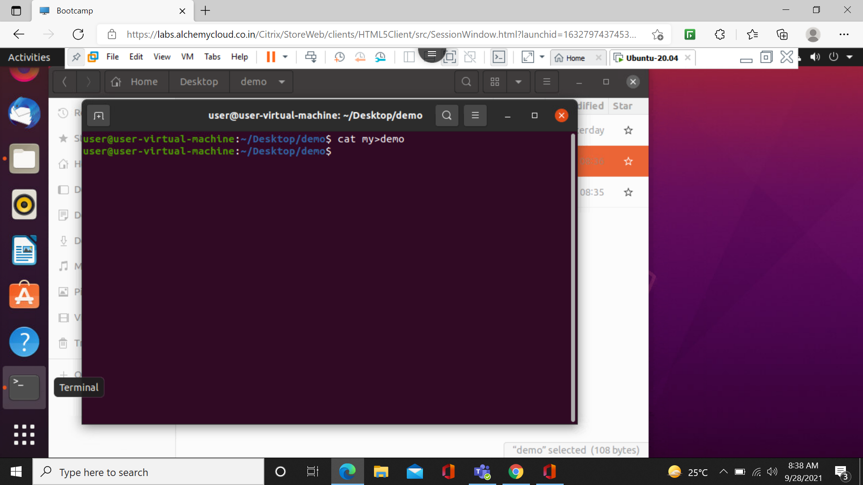

Cat f1>>f2:

This command is used for transposing data of f1 into f2 without deleting it. 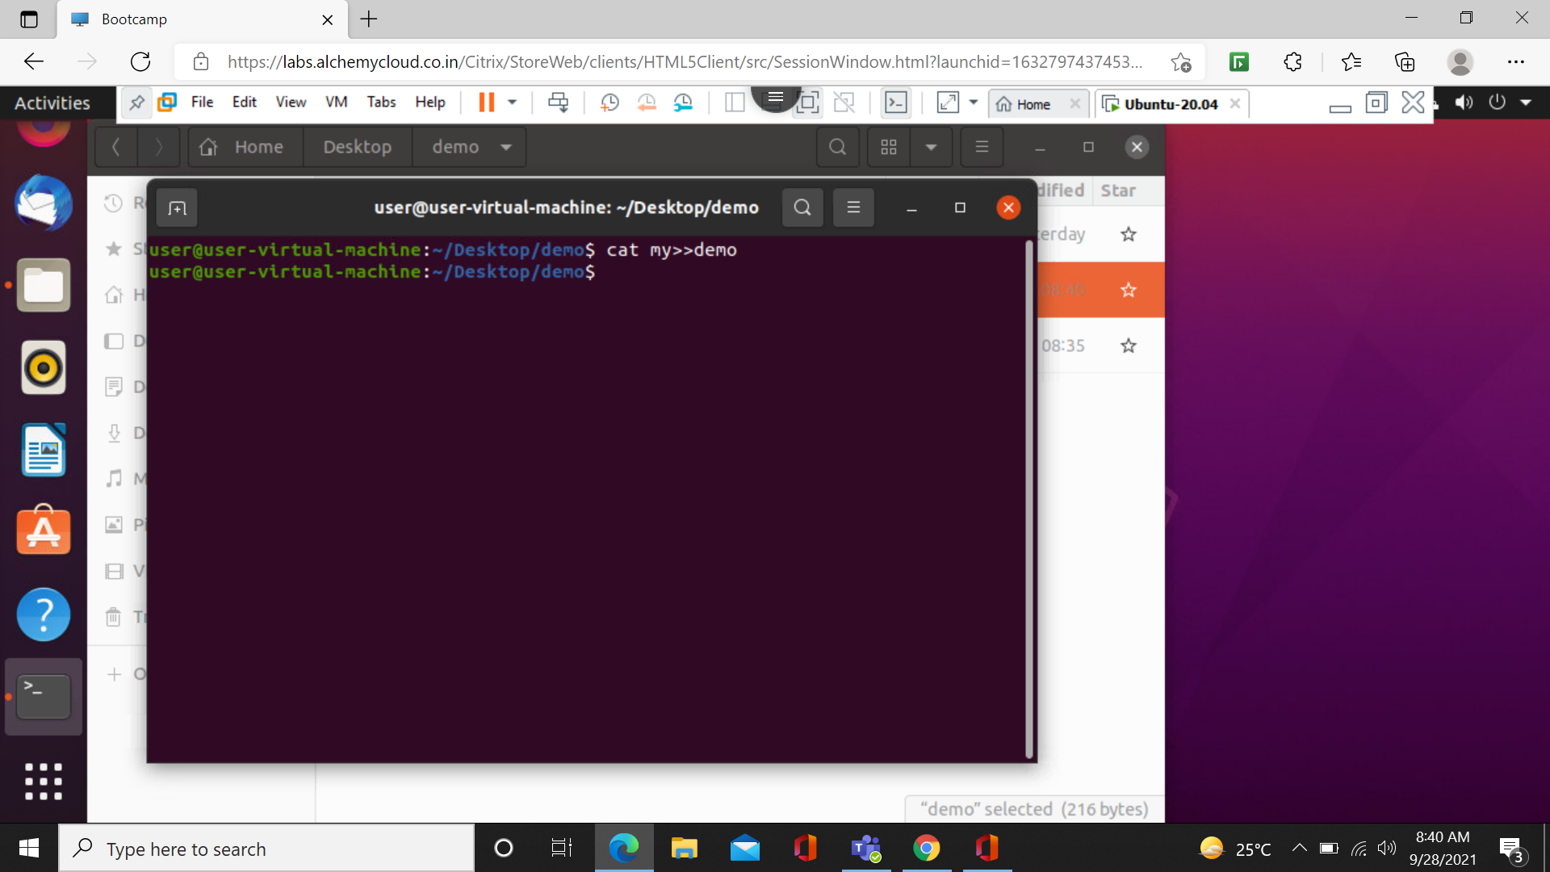

Cat –E command:

This command is used for detecting ‘enter ‘ is text.$ represent enter.

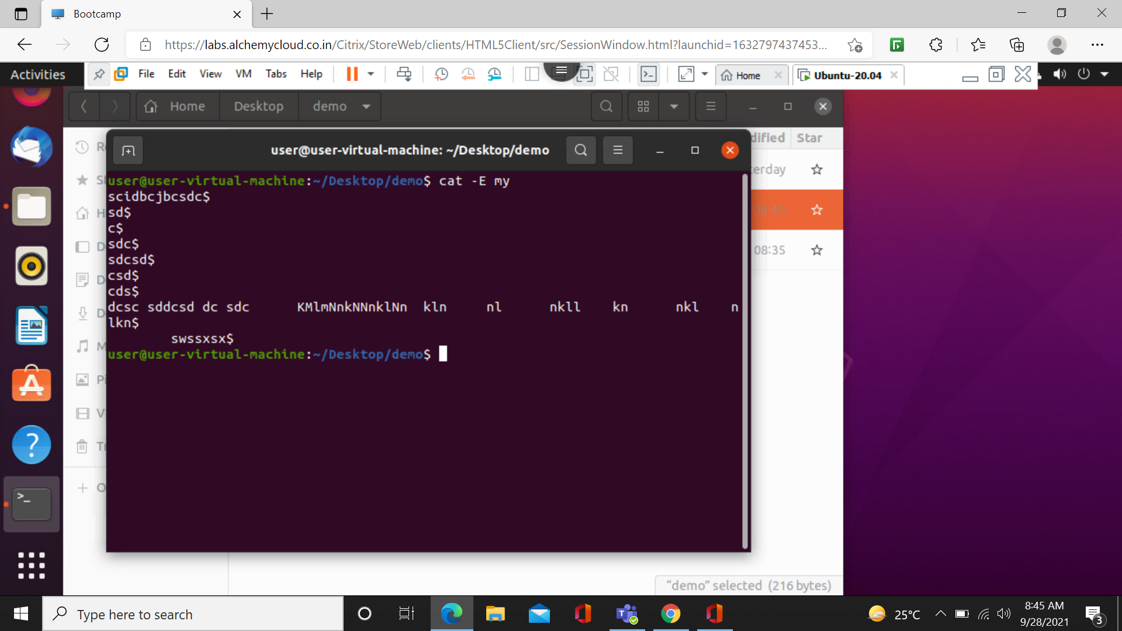

Cat –t command:

This command is used for detecting Tab key in text.^ represents tab.

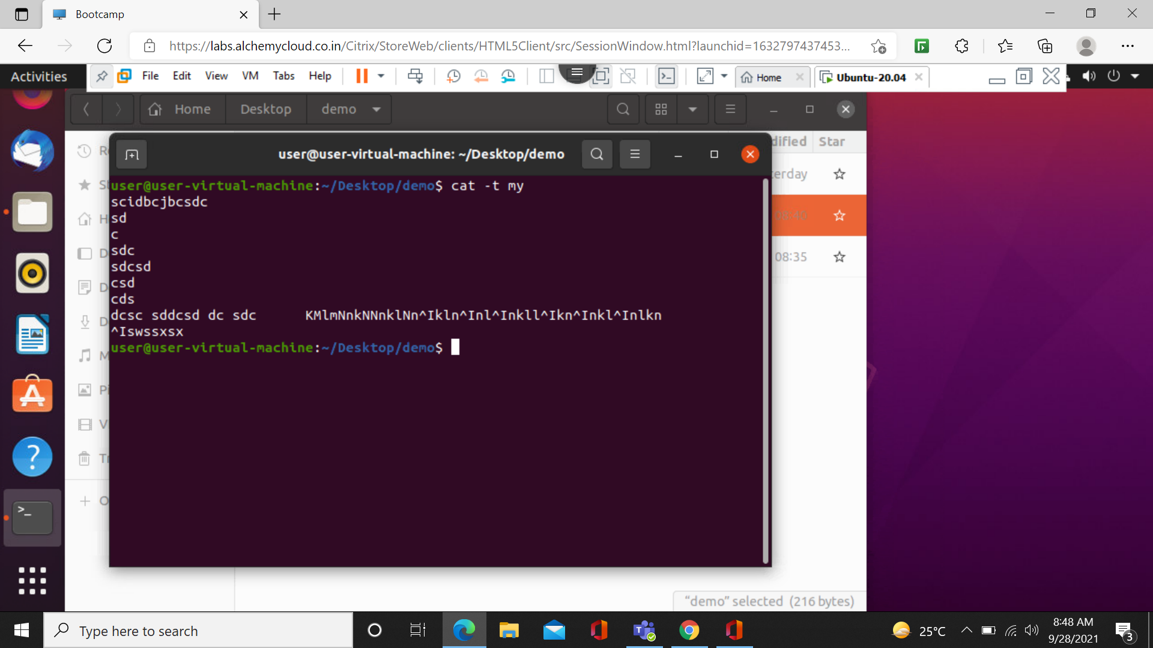

Cat –tE command:

This command is used to detect Enter and Tab at once.

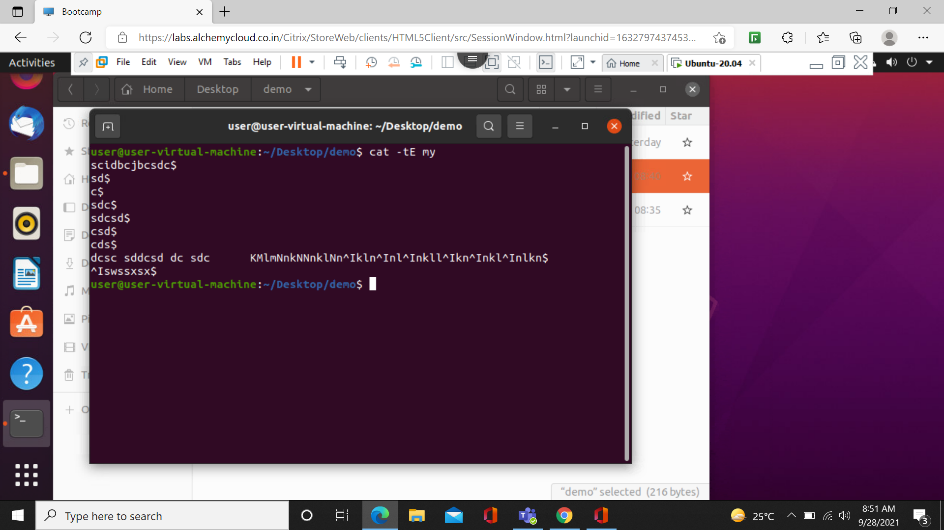

Cat > new command:

It is use to create new file.

